SIMATS ENGINEERING
ASSESSMENT TOOL
COURSE NAME: Theory of Computation
COURSE CODE: CSA1304
COURSE OUTCOME COVERED

CO1: Analyse fundamental mathematical concepts of automata theory for formal languages and decision problems. (BL:3)
Assessment Tool Weightage: 40%

QUESTIONS: 5 Total Marks:25
Duration: 1 Hour
Analytical Problem
Code of Conduct:
I S. Harish (192511119) (Name / Reg No) certify that this submission is my original work and that I have adhered to the guidelines specified for this assessment.
I understand that any violation of academic integrity rules will result in disciplinary action.

Signature of the student:

SIMATS ENGINEERING
ASSESSMENT TOOL
1.Consider the NFA given below which accepts some language L over the alphabet ��={a,b}. Construct a DFA that represents the same language L
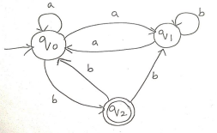
SOLUTION:
Transition table of the given NFA (read from the question figure):
State | a | b
→ q0 | {q0, q1} | {q2}
q1 | {q0} | {q1}
* q2 | ∅ | {q0, q1}

DFA state | On a | On b
→ {q0} | {q0, q1} | {q2}
{q0, q1} | {q0,q1} ∪ {q0} = {q0, q1} | {q2} ∪ {q1} = {q1, q2}
* {q2} | ∅ | {q0, q1}
* {q1, q2} | {q0} ∪ ∅ = {q0} | {q1} ∪ {q0,q1} = {q0, q1}
∅ (trap) | ∅ | ∅

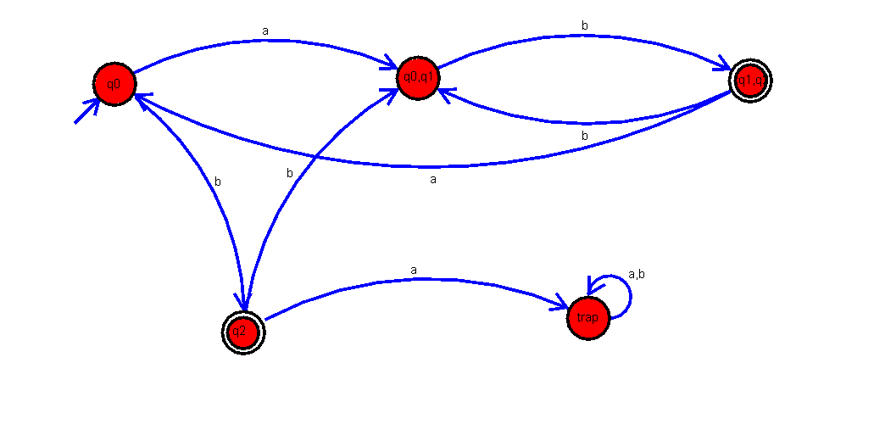
2. Let L be the language of words of length at least 2 who’s last two letters are difference from each other. For example, abaab is in L but not bb, Construct an NFA for L, then draw the equivalent DFA
SOLUTION:
NFA:
Formal definition of the NFA: N = (Q, Σ, δ, q0, F) with Q = {q0, q1, q2, q3}, Σ = {a, b}, start state q0 and F = {q3}. The transition function δ is:
State | a | b
→ q0 | {q0, q1} | {q0, q2}
q1 | ∅ | {q3}
q2 | {q3} | ∅
* q3 | ∅ | ∅

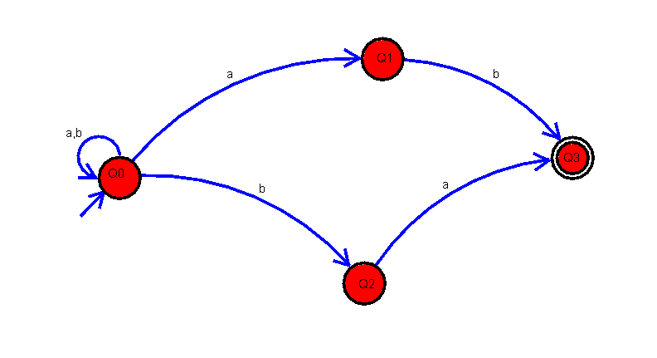
DFA:
DFA state | Subset | a | b
→ A | {q0} | B | C
B | {q0, q1} | B | D
C | {q0, q2} | E | C
* D | {q0, q2, q3} | E | C
* E | {q0, q1, q3} | B | D

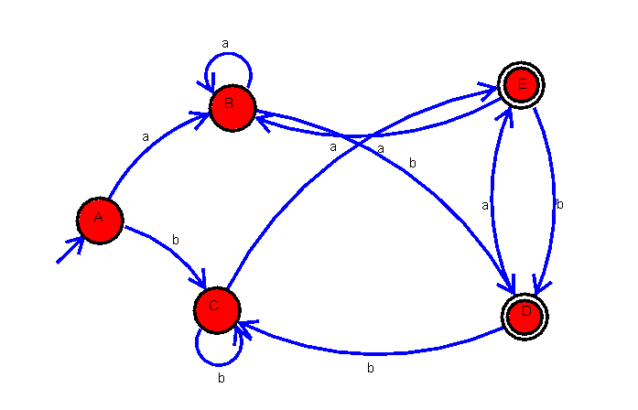
3. Design a Nondeterministic Finite Automata (NFA) that takes a binary string as input and accepts the string only if the last two digits are the same (either 00 or 11). Write the formal definition of the NFA. Also show that the string 01011 is accepted by the NFA.
SOLUTION:
Trace for 01011
One accepting path is q0 —0→ q0 —1→ q0 —0→ q0 —1→ q2 —1→ qf. The last two input digits are 11, so the string 01011 is accepted. (Other nondeterministic paths may die; one accepting path is sufficient.)
Symbol read | Set of current states
(start) | {q0}
0 | {q0, q1}
1 | {q0, q2}
0 | {q0, q1}
1 | {q0, q2}
1 | {q0, q2, q3}

Formal definition of the NFA: N = (Q, Σ, δ, q0, F) where Q = {q0, q1, q2, q3}, Σ = {0, 1}, q0 is the start state, F = {q3}, and δ is:
State | 0 | 1
→ q0 | {q0, q1} | {q0, q2}
q1 | {q3} | ∅
q2 | ∅ | {q3}
* q3 | ∅ | ∅

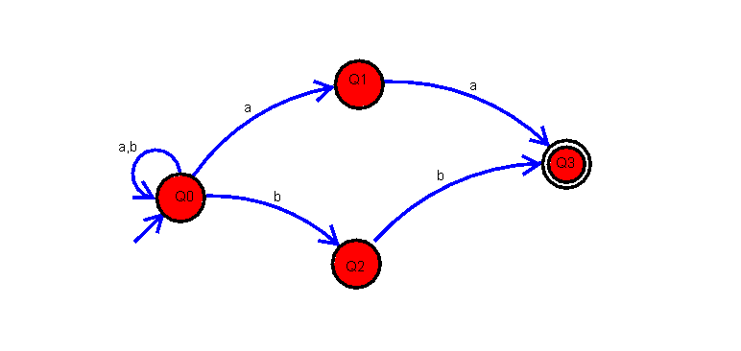

4. Consider the NFA given below which accepts the language representing the set of all strings having 001 as a substring over the alphabet ��= {0,1}. Construct a DFA that represents the same language.
SOLUTION:
The NFA for the language of strings containing 001 is taken to be: q0 loops on 0 and 1, q0 –0→ q1 –0→ q2 –1→ q3, and q3 loops on 0 and 1, with q3 as the final state. Its transition table is:
State | 0 | 1
→ q0 | {q0, q1} | {q0}
q1 | {q2} | ∅
q2 | ∅ | {q3}
* q3 | {q3} | {q3}

Subset construction:
DFA state | Subset | 0 | 1
→ A | {q0} | {q0, q1} | {q0}
B | {q0, q1} | {q0, q1, q2} | {q0}
C | {q0, q1, q2} | {q0, q1, q2} | {q0, q3}
* D | {q0, q3} | {q0, q1, q3} | {q0, q3}
* E | {q0, q1, q3} | {q0, q1, q2, q3} | {q0, q3}
* F | {q0, q1, q2, q3} | {q0, q1, q2, q3} | {q0, q3}

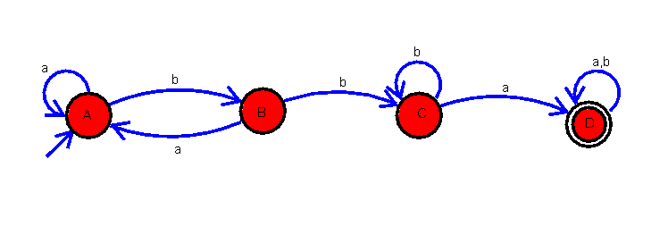

5. A NFA with ε-transitions is given below. Find ε-closure for each state and design an equivalent DFA which accepts the same language. Draw its transition table and mark the initial and final states
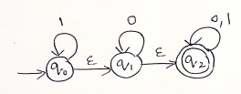
SOLUTION:
State | ε-closure
q0 | {q0, q1, q2}
q1 | {q1, q2}
q2 | {q2}

DFA:
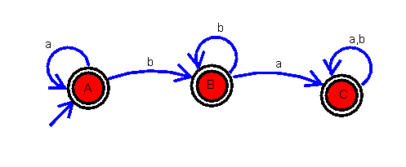
DFA state | Subset | 0 | 1
→ *A | {q0, q1, q2} | B | A
*B | {q1, q2} | B | C
*C | {q2} | C | C

Transition table of the given ε-NFA (q0 loops on 1, q1 loops on 0, q2 loops on 0 and 1; q0 –ε→ q1 –ε→ q2; q2 is final):
State | 0 | 1 | ε
→ q0 | ∅ | {q0} | {q1}
q1 | {q1} | ∅ | {q2}
* q2 | {q2} | {q2} | ∅

Each DFA move is computed as ε-closure (δ (S, symbol)), where δ (S, symbol) is the union over the states of S:
DFA state | On 0 | On 1
→ * A = {q0, q1, q2} | δ = {q1} ∪ {q2}, closure = {q1, q2} = B | δ = {q0} ∪ {q2}, closure = {q0, q1, q2} = A
* B = {q1, q2} | δ = {q1} ∪ {q2}, closure = {q1, q2} = B | δ = ∅ ∪ {q2}, closure = {q2} = C
* C = {q2} | δ = {q2}, closure = {q2} = C | δ = {q2}, closure = {q2} = C

SIMATS ENGINEERING
ASSESSMENT TOOL

RUBRICS FOR CALCULATION

Criteria | Weightage | Level 4 –  Exemplary (5 Marks) | Level 3 –  Proficient (4 Marks) | Level 2 –  Developing (2–3 Marks) | Level 1 –  Beginning (0–1 Mark)
Conceptual  Understanding | 30 | Demonstrates clear and complete  understanding of the concept | Good  understanding with minor gaps | Basic  understanding with some  misconceptions | Poor or  incorrect  understanding
Accuracy of Answer | 25 | Completely correct answer with no errors | Mostly correct with minor  errors | Partially correct with noticeable errors | Incorrect or  irrelevant  answer
Application of Knowledge | 20 | Correctly applies concepts to solve the  question/problem | Applies  concepts with minor mistakes | Limited or partially correct application | No, or incorrect application
Completeness of Response | 15 | Covers all required parts of the  question | Covers most parts with minor omissions | Covers only some parts | Incomplete or missing  response
Clarity &  Presentation | 10 | Clear, concise, and well-organized answer | Understandable with minor  issues | Somewhat unclear or poorly  structured | Difficult to  understand

